`1

**Scholar & Core Awards**

Congratulations to the following students in grades 2-5 who received recognition for exhibiting the core value and being scholars!

|  |  |  |
| --- | --- | --- |
| ***Class*** | ***Core Value for October*** | ***Scholar Recipient for October*** |
| ***101*** | Isabelle S. | David W. |
| ***102*** | Andrew S. | Gabrielle F. |
| ***103*** | Adiyat Z, Johnny C. | Gabriella A. |
| ***104*** | Jarellys M. | Ayden G. |
| ***201*** | Aisha A. | Jacinth J. |
| ***202*** | Chrisy F. | Anthony P. |
| ***203*** | Sadia H. | Bryan AP |
| ***204*** | Mia J | Cameron K. |

**Save the date: Lower campus movie night will be rescheduled to January 18 from 5-7.**

**Principal Corner**

Holiday Greetings! As we close out another calendar year, I want to share my appreciation for the partnership between families and staff at the Roosevelt to develop your children into lifelong learners. Please continue to ask your children about what they are learning! Enjoy the holiday break.

***Happy Holidays from the staff of the Roosevelt K-8 School***

***Roosevelt School***

***Big Time News***

***December 1, 2017***

Franklin

 

Big Time News – November 1, 2016

**Core value for December**

1. Perseverance steadfastness in doing something despite difficulty or delay in achieving success.

.

*December 1*

*Marks close*

*K-5*

*Pizza Sale*

*School Preview 10:30*

*December 4 -8*

*Upper Campus Book Fair*

*December 7 family shopping 5:pm*

*12/11-15*

*Lower Campus Book*

*Fair*

*December 15 Progress reports go home*

*December 18*

*5:30*

*Drama club parent meeting*

*Drama Club Booster meeting 6:30*

*December 21*

*pajama day lower campus*

*Winter recess*

*December 22 – January 2*

*School reopens January 3, 2018*

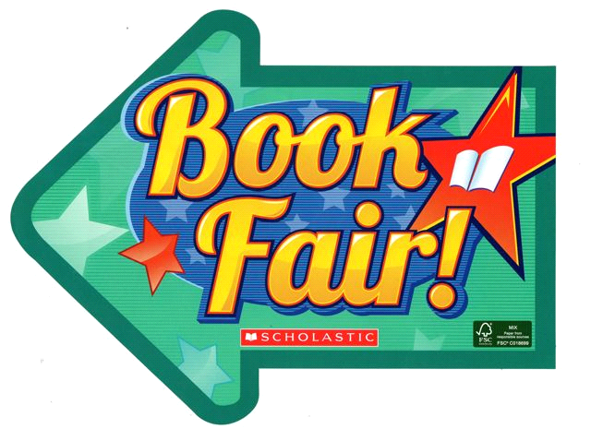

Scholastic Book Fair is back at the Roosevelt!!!

Upper Campus Book Fair

dates Monday Dec 4th through

Friday Dec 8th

Upper Campus Book Fair homepage:

<http://www.scholastic.com/bf/fdrooseveltupper>

Special evening shopping hours Thursday Dec 6, 5-7pm

Lower Campus Book Fair dates

Monday Dec 11th through Dec 15th

Lower Campus Fair homepage:

<http://www.scholastic.com/bf/froosevelthemenwaycampus1>

Special shopping hours are 8:15-9AM and 3-3:45 daily.

**Scholar & Core Awards**

Congratulations to the following students in grades

K-1 who received recognition for exhibiting the core value and being scholars!

|  |  |  |
| --- | --- | --- |
| **Class** | **Core Value for October**  **Cooperation** | **Scholar Recipient** |
| Green rm. | Anthony V. | Neissa M. |
| Yellow rm. | Carmen | Erianny |
| Red rm. | Hannah B | Ronald |
| Orange rm. | Allison | Josmaly |
| Blue rm. | Ezequiel | Colbert |
| Purple rm. | Kamirah D. | Clark R. |

**LC Scholar Recipient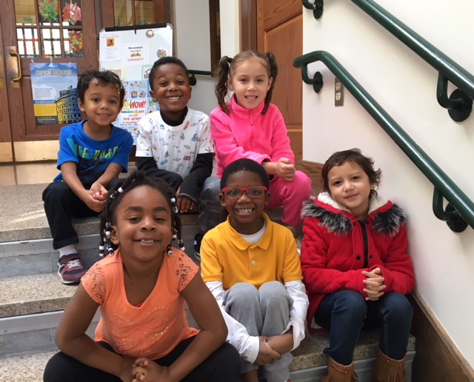LC Core Recipient**

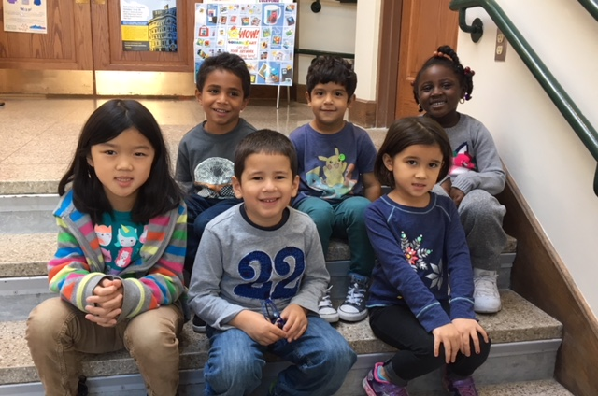

# 

**Drama Club Bottle and Can Driveay. We appreciate it in advance.https://ssl.gstatic.com/ui/v1/icons/mail/images/cleardot.gif**

**Grade 1 Update**

The first grade learned about the Pilgrims and Wampanoags through their social studies unit. They shared their learning through drama, poetry and song in their performance of **"The First** **Thanksgiving."** A wonderful time was had by all.

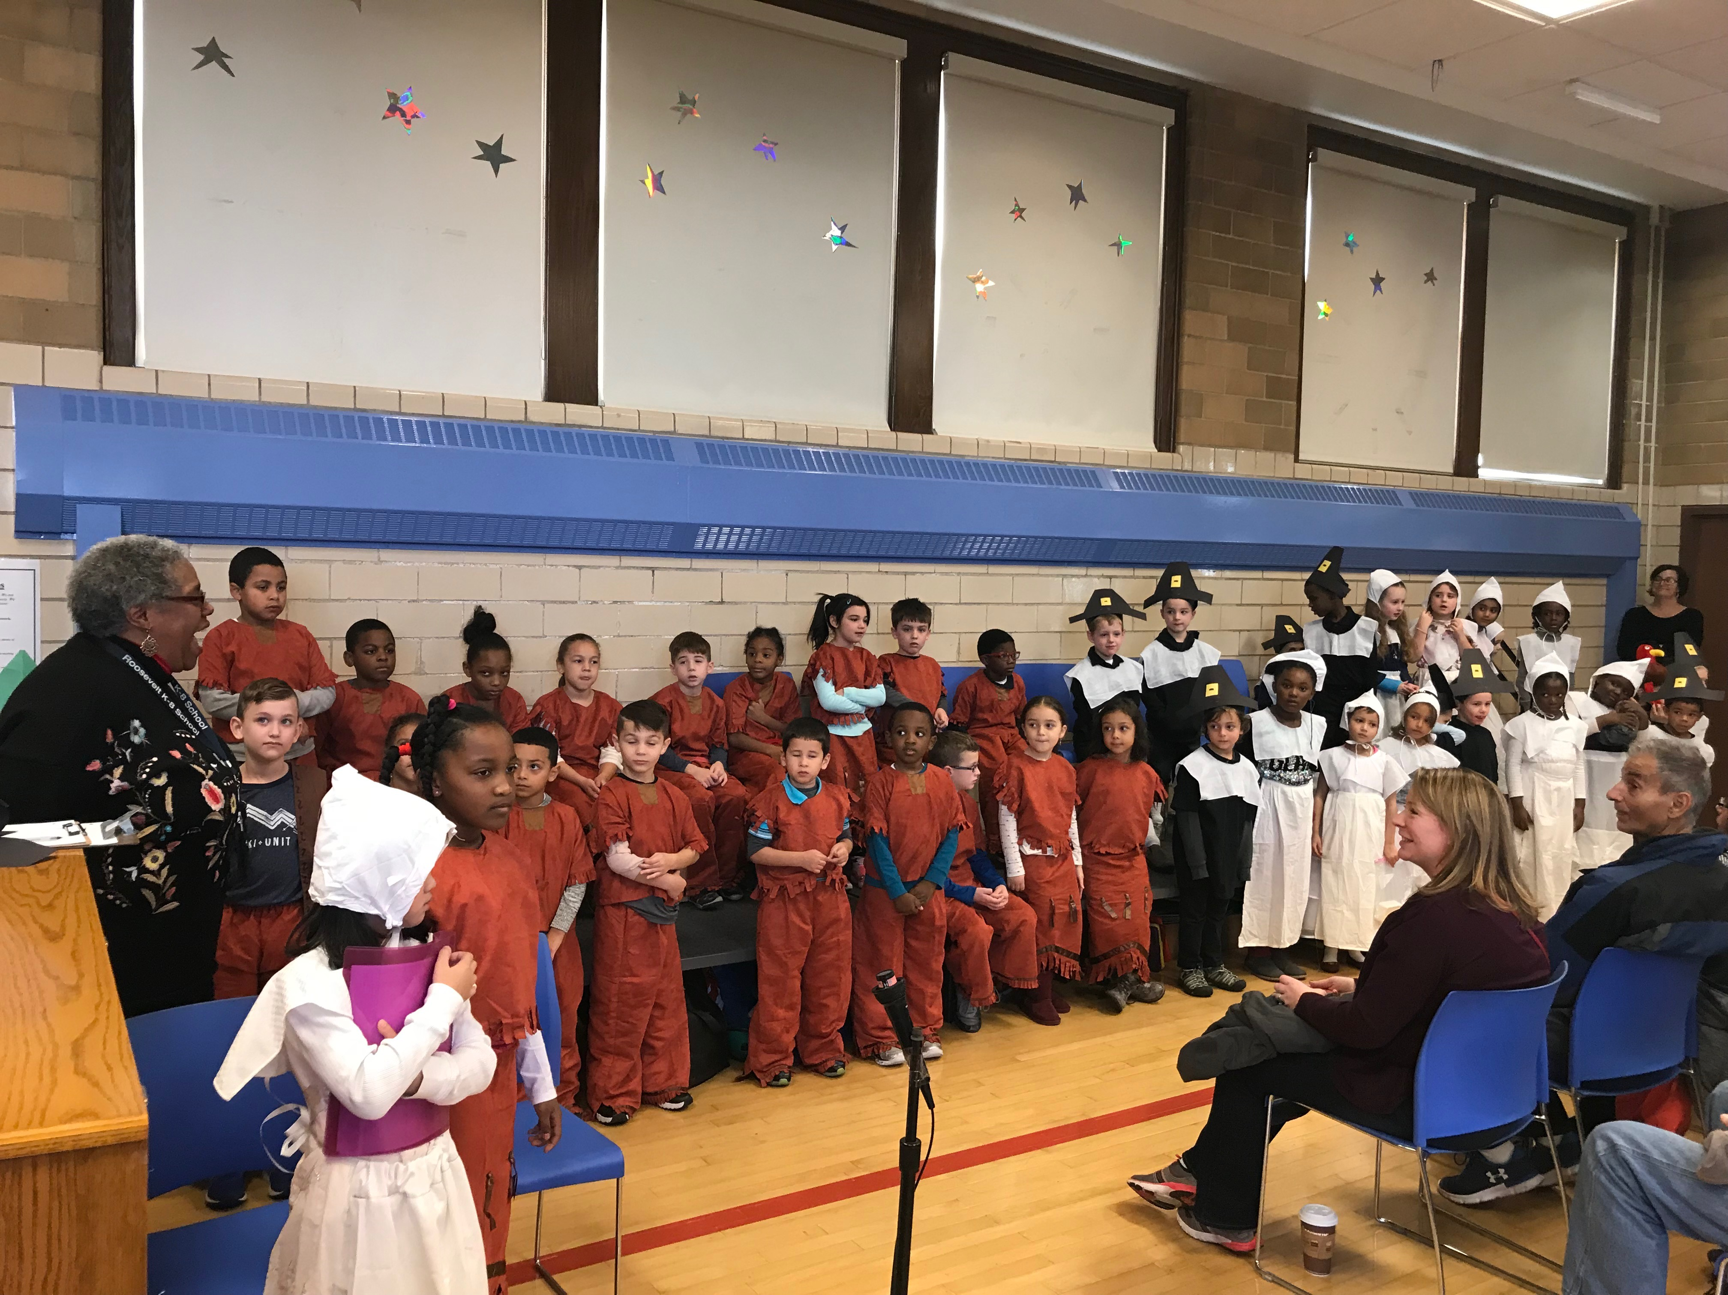

**Grade 2 Update**

Grade 2 ended November with our Thanksgiving unit, in which we learned about the lives of Pilgrims and Native People in the 1600s.  We had academic conversations and wrote about whether we would like to have been a Pilgrim or a Wampanoag, using evidence from our readings to support our claims. Most students didn’t want to be Pilgrims because of all the chores they had to do!

We topped off our unit with our Annual Thanksgiving Pie Tasting event. Pumpkin pie was the favorite in Room 103 and blueberry was the favorite in Room 104.

Second graders recently took a field trip to the Moakley Federal Courthouse in Boston, where all students participated in a mock trial, acting as jurors, judges, clerks, and attorneys.  We had a memorable lesson in civics and the court process.

This month we’ll be learning about fractions in math, reading a play, “The Bremen Town Musicians”, and making robots.

**6th-8th Girls Volleyball Team**

The Girls Volleyball Team is off to a great start this year with a 2-0 record!  The Team beat Mildred Ave. on Thursday Nov. 9th in two games, 25-6 and 25-5. on the following Wednesday Nov. 15th, they beat the Curley K-8 in two games, 25-7 and 25-10.

**LC Art Show**

Parents are invited to attend an Art Show on Thursday December 14th from 3:00-4:30PM. Details will follow.

**Principal Lynda-Lee Sheridan**

**Assistant Principal Bannet Steele**

**Upper Campus**: 95 Needham Road, Hyde Park, MA 02136

P: 617-635-8676 F: 617-635-8679

**Lower Campus**: 30 Millstone Road, Hyde Park, MA 02136

P: 617-635-9280 F: 617-635-9284*P:*

*Please visit our website at* ***bostonpublicschools.org/Roosevelt***

*To find all general information about the school and classroom web pages. You can also stay informed through* ***Twitter @RooseveltK8BPS***

**Drama Club Announcements**

**December Calendar**

December 1st: Pizza Sale Fundraiser

December 8th: Audition packets & deposit due

December 12th or 13th: The Wizard of Oz Auditions

December 18th: Mandatory Parent Meeting

December 19th: 1st Rehearsal

**The Wizard of Oz**

Audition packets are available in the main office. Please read this information carefully and return your packet and deposit to Ms. Fredericks by Dec. 8th.

**Pizza Sale**  
We will have a pizza sale on Friday, December 1st to support our performances this year. Students will be able to purchase slices of pizza for $2 each and water bottles or juice boxes for $1 each.

**The Prince and The Pauper**

We are so proud of all students who participated in this production. You did an amazing job and we hope you all return for The Wizard of Oz!

**Drama Club Bottle and Can Drive**

The Drama Boosters Club will hold a bottle and can drive on Saturday Feb 10th 2018. If space allows please consider saving your bottles and cans to bring on that day. We appreciate it in advance.

**https://ssl.gstatic.com/ui/v1/icons/mail/images/cleardot.gif**

**Girl Scouts**

The Roosevelt Girl Scouts will be holding a toy, food and coat drive from December 1st- December 15th.

We will be collecting new toys for families in need, warm coats for kids and adults for the “Coats for Kids” drive and non-perishable foods for the Hyde Park food pantry. There will be boxes in the front hall at Upper and Lower Campus.

Thank you in advance for your support!